DTMF CONTROLLED ROBOT USING ARDUINO:

AIM: Designing DTMF Controlled Robot Using Arduino Uno.

Hardware requirement:

• wheel Arduino UNO with usb cable

• DC Motor - 9V

• Mobile Phone

• DTMF decoder Module

• Motor Driver L293D

• 9 Volt Battery

• Battery Connector

• Aux wire

• Robot Chasis with Jumper wires

* Laptop

Software Requirement:

* Aurdino IDE 1.8.19

CIRCUIT DIAGRAM:

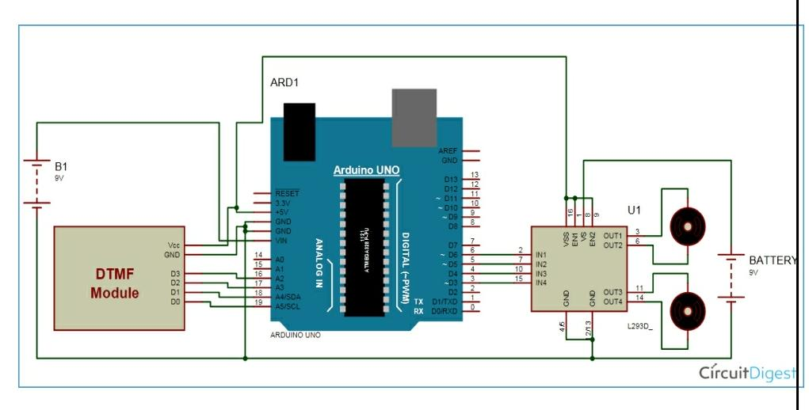

PROCEDURE:-

* Go to <https://www.arduino.cc/en/Main/Software> - select windows 7 and newer & select just Download.
* Double click the arduino-1.8.19-windows setup file & proceed with installation by simply clicking ‘agree & next ‘ in installation pop-up window.
* Double click Arduino icon. Go to Menu - File → New.
* Write c program for DTMF controlled robot.
* go to menu bar &click on verify ✅ option.(clear if any errors are there)
* Go to menu – Tools – Board - Arduino Uno R3.
* Connect your Arduino board to laptop using it’s usb cable
* Go to Tools → Port - COM3(Arduino uno)
* go to Menu – select the right arrow icon ➡ (Upload).
* Then remove the usb cable from Arduino board
* Connect the circuit as per circuit diagram
* Make sure all the connections are made properly & avoiding loose connections.
* Switch on the power supply and verify its functionality with theoretical.

PIN CONNECTIONS:

* Motor Driver’s input pins 2,7,10 and 15 are connected at Arduino digital pin number 6,5,4 and 3 respectively.
* DTMF decoder pin D0,D1,D2,D3 are directly connected with Arduino’s pin number 19,18,17,16 respectively.
* DC Motor 1 is connected to output pin f Motor Driver pins 1 and 6.
* DC Motor 2 is connected to output pin of Motor Driver’s pins 11 and 14.
* Two 9V batteries are connected at Motor Driver IC pin number 8.

0BSERVATIONS:

* When we press number 5 in mobile the robot stop moving.
* When we press number 6 in mobile the robot moves to right.
* When we press number 4 in mobile the robot moves to left.
* When we press number 2 in mobile the robot moves in forward direction.
* When we press number 3 in mobile the robot moves in backward direction.

RESULT:

Thus designed DTMF Controlled Robot on Arduino Uno & verified its functionality with theoretical.